Insert Paper Title (Use “JEASD Title” Style)
First Author^{1*}, Second Author², Third Author³
¹First author’s affiliation
²Second author’s affiliation
³Third author’s affiliation
*Email: corresponding_author@uomustansiriyah.edu.iq
Article Info |  |  | Abstract (10 PT)
Received | dd/mm/yyyy |  | The abstract should be between 150-200 words. It should briefly indicate the general scope and state the main results obtained, methods used, the value of the work and the conclusions drawn. No figure numbers, table numbers, references or displayed mathematical expressions should be included. Emphasis should be on what was found more than what was done. Use the “Abstract” style. Do not use abbreviations in the abstract. The abstract should be between 150-200 words. It should briefly indicate the general scope and state the main results obtained, methods used, the value of the work and the conclusions drawn. No figure numbers, table numbers, references or displayed mathematical expressions should be included. Emphasis should be on what was found more than what was done. Use the “Abstract” style. Do not use abbreviations in the abstract.
Revised | dd/mm/yyyy
Accepted | dd/mm/yyyy
Keywords: First keyword, Second keyword, Third keyword, Fourth keyword, Fifth keyword

1. Introduction - First Level Heading (Capitalize Each Word, use “Heading 1” style).
Use the “JEASD Paragraph” style. The introduction should set the paper’s tone by providing a clear statement of the study, the relevant literature on the subject, and the proposed approach or solution. The introduction should be general enough to attract a reader’s attention from a broad range of scientific disciplines. This template, created in MS Word 2010, provides authors with most of the formatting specifications needed for preparing their papers. Margins, line spacing, and type styles are built-in; examples of the type styles are provided throughout this document.
The bullets should be used as:
- Bullet one (Use “Paragraph - bullets)” style).
- Bullet two (Use “Paragraph - bullets” style).

Numbers/List should be as follows:
- Number 1 (Use “Paragraph - numbers” style)
- Number 2 (Use “Paragraph - numbers” style)

2. Custom Title - First Level Heading (Capitalize Each Word, use “Heading 1” Style).

2.1. General - Second Level Heading (Capitalize Each Word, use “Heading 2” style).
First, confirm that you have the correct template for your paper size. This template has been tailored for output on the A4 paper size. Do not bother about the header or footer or content of the article, just paste your content in the template, replacing the content. Please fit your article in this template exactly following the author’s guidelines without any deviation.

2.2. Margins and Line Spaces - Second Level Heading (Capitalize Each Word, use “Heading 2” style).
The template is used to format your paper and style the text. All margins, line spaces, and text fonts are prescribed; please do not alter them.

2.2.1. Comments - Third Level Heading (Sentence case, use “Heading 3” Style).
Before you begin to format your paper, first write and save the content as a separate text file. Keep your text, and graphic files separate until after the text has been formatted and styled. Do not add any kind of pagination anywhere in the paper. Do not number text heads, the template will do that for you.

2.2.2. Abbreviations - Third Level Heading (Sentence case, use “Heading 3” Style).
Abbreviations should be defined at first mention in the abstract and again in the main body of the text and used consistently thereafter. Do not use abbreviations in the title or heads unless they are unavoidable. A list of symbols should be inserted before the references if such a list is needed. Symbols must be written clearly. The international system of units (SI units) should be used in the text, tables and figures. Symbols for physical quantities in the text should be written in Italics (e.g., v, T, etc.). Symbols for units containing letters should be in plain text (e.g., Pa, m, etc.).

2.2.3. Equations - Third Level Heading (Sentence case, use “Heading 3” Style).
When writing mathematics, avoid confusion between characters that could be mistaken for one another, e.g., the letter ‘l’ and the figure one. Refer to equations using round brackets, e.g. (1). Use MS equation editor. Avoid using “picture” for equations.
$X+Y=Z$ (1)
$X_{1}+Y^{2}=B$ (2)
Note that the equation is centered using a center tab stop. Be sure that the symbols in your equation have been defined before or immediately following the equation. Use “(1)”, not “Eq. (1)” or “equation (1)”, except at the beginning of a sentence. For example, “Equation (1) is used to describe …etc.”

3. Figures and Tables - First Level Heading (Capitalize Each Word, use “Heading 1” Style).

3.1. Figures - Second Level Heading (Capitalize Each Word, use “Heading 2” style).
Figure captions should be below the figures. Insert figures and tables after they are cited in the text. Use the abbreviation “Fig. 1”, even at the beginning of a sentence. When placing more than two figures and photos under the same number of titles, assign subtitles by dividing each figure and photo by (a) or (b). The font style and size used in
The figures should be equal to the font used in writing the manuscript (i.e. Times New Roman size 10). Do not use a shadow or frame around the figure. Multi-curve graphs should have individual curves marked with a symbol; the symbol’s meaning should be explained in the figure caption. Good quality black-and-white photographs or scanned images should be supplied for the illustrations. Provide high-resolution figures.
Use “Section Breaks – Continuous” if necessary to expand a figure into one column.
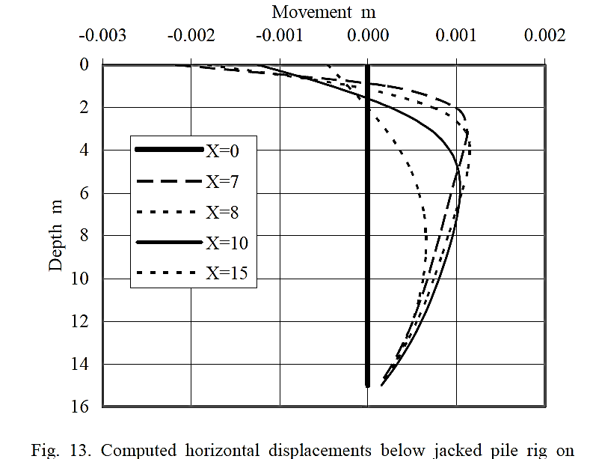
Figure 1. Black and white figure without shading or frame (Use “Figures caption” style) (Sentence case)

Figures should be inserted after their first mention. After inserting a figure in the manuscript, do the following steps:
- Select the figure.
- Click the “Layout Options button,” which is found lingering near the image’s upper right corner.
- Choose “In line with Text.”

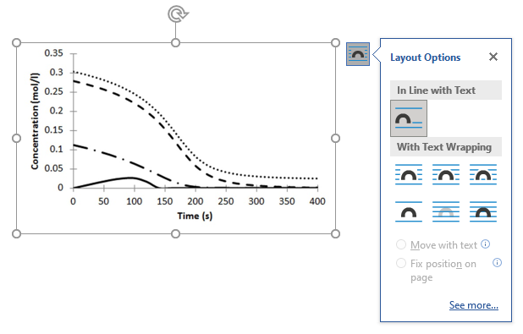
Figure 2. Figure layout.

3.2. Tables - Second Level Heading (Capitalize Each Word, use “Heading 2” Style).
Insert tables after they are cited in the text. Tables are referred to in the text by “Table X.” (capital T). Table heads should appear above the tables. Avoid any colors or shadings in the table.
Use “Section Breaks – Continuous” if necessary to expand the tables into one column.
Use “Tables caption” style for table caption and “Table body” style for text inside the table. The first raw should be bold. Do not use shading in the tables.
Remove the inside borders from the table. Borders are only above and below the first raw and below the last raw.
Tables must be in editable format. Avoid using pictures.
Table 1. Insert table caption here. (Use “Table caption” style, Sentence case)
Column 1 | Column 2 | Column 3 | Column 4
Row 1 | Row 1 | Row 1* | Row 1
Row 2 | Row 2 | Row 2 | Row 2
Row 3 | Row 3 | Row 3 | Row 3
Row 4 | Row 4 | Row 4 | Row 4
Row 5 | Row 5 | Row 5 | Row 5
Row 6 | Row 6 | Row 6 | Row 6
Any footnotes should be indicated by the use of a superscript “*”

Go to the properties of the table. Select “centered” alignment and “None” from text wrapping.

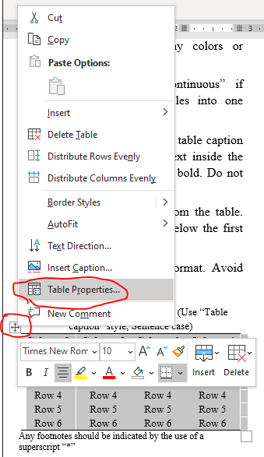
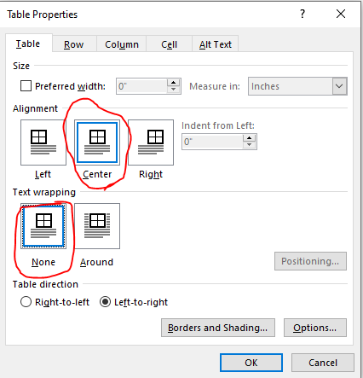
Figure 3. Table properties.

4. Conclusions - First Level Heading (Capitalize Each Word, use “Heading 1” style).
The conclusions section should be written in one paragraph instead of points. The conclusions section should highlight the major, firm discoveries, and state the added value of the main finding, without literature references. A conclusion should point out the distinguished results of the achieved work and do not replicate the abstract. A conclusion may suggest recommendations for work extension and new applications.

Acknowledgements - First Level Heading (Capitalize Each Word, use “Heading 1” Style).
The author(s) may express his/her appreciation to relevant agencies and related personnel providing financial support or academic advice to his or her research.

Abbreviations (Optional) - First Level Heading (Capitalize Each Word, use “Heading 1” Style).
A list of symbols should be inserted before the references if such a list is needed. Sort in alphabetical order.
A | Coefficient matrix
E | Modulus of elasticity
R_{f} | Failure ratio
t | Time
γ | Unit weight of material
ѵ | Poisson’s ratio
φ | Friction angle
εv | Volumetric strain

Conflict of interest - First Level Heading (Capitalize Each Word, use “Heading 1” style).
The author(s) should mention that the publication of this article causes no conflict of interest. A conflict-of-interest statement must be placed in the manuscript as below: “The authors declare that there are no conflicts of interest regarding the publication of this manuscript”.

Author Contribution Statement
The Author Contributions section should specify the exact contributions of each author in a narrative form. For instance:
Authors A.B. and C.D: proposed the research problem.
Author A.B.: developed the theory and performed the computations.
Author C.D.: verified the analytical methods and investigated [a specific aspect] and supervised the findings of this work.
Both authors discussed the results and contributed to the final manuscript.

Data Availability (Optional)
This section is optional and can be added by the author(s) if applicable, to address the availability of non-standard data used in the paper.

References - First Level Heading (Capitalize Each Word, use “Heading 1” style).
If you use references management applications like Endnote, Mendeley, or LaTeX, simply use IEEE style for referencing. If not, you can follow the guideline below:

Basic format for periodicals:
J. K. Author, “Name of paper,” Abbrev. Title of Periodical, vol. x, no. x, pp. xxx-xxx, Abbrev. Month, year, doi: 10.1109.XXX.1234567.

Periodicals using article numbers:
J. K. Author, “Name of paper,” Abbrev. Title of Periodical, vol. x, no. x, Abbrev. Month, year, Art. no. xxxxx, doi: 10.1109.XXX.1234567.

Examples:
- J. U. Duncombe, “Infrared navigation—Part I: An assessment of feasibility,” IEEE Trans. Electron Devices, vol. ED-11, no. 1, pp. 34–39, Jan. 1959, doi: 10.1109/TED.2016.2628402.
- E. P. Wigner, “Theory of traveling-wave optical laser,” Phys. Rev., vol. 134, pp. A635–A646, Dec. 1965.
- P. Kopyt et al., “Electric properties of graphene-based conductive layers from DC up to terahertz range,” IEEE THz Sci. Technol., to be published, doi: 10.1109/TTHZ.2016.2544142. (Note: If a paper is still to be published, but is available in early access, please follow ref [5]).)
- R. Fardel, M. Nagel, F. Nuesch, T. Lippert, and A. Wokaun, “Fabrication of organic light emitting diode pixels by laser-assisted forward transfer,” Appl. Phys. Lett., vol. 91, no. 6, Aug. 2007, Art. no. 061103.
- D. Comite and N. Pierdicca, "Decorrelation of the near-specular land scattering in bistatic radar systems," IEEE Trans. Geosci. Remote Sens., early access, doi: 10.1109/TGRS.2021.3072864. (Note: This format is used for articles in early access. The doi must be included.)
- H. V. Habi and H. Messer, "Recurrent neural network for rain estimation using commercial microwave links," IEEE Trans. Geosci. Remote Sens., vol. 59, no. 5, pp. 3672-3681, May 2021. [Online]. Available: https://ieeexplore.ieee.org/document/9153027

Basic format for books:
J. K. Author, “Title of chapter in the book,” in Title of Published Book, xth ed. City of Publisher, (only U.S. State), Country: Abbrev. of Publisher, year, ch. x, sec. x, pp. xxx–xxx.

Examples:
- G. O. Young, “Synthetic structure of industrial plastics,” in Plastics, 2nd ed., vol. 3, J. Peters, Ed. New York, NY, USA: McGraw-Hill, 1964, pp. 15–64.
- W.-K. Chen, Linear Networks and Systems. Belmont, CA, USA: Wadsworth, 1993, pp. 123–135.
- Philip B. Kurland and Ralph Lerner, eds., The Founders’ Constitution. Chicago, IL, USA: Univ. of Chicago Press, 1987, Accessed on: Feb. 28, 2010, [Online]. Available: http://press-pubs.uchicago.edu/founders/

Basic format for handbooks:
Name of Manual/Handbook, x ed., Abbrev. Name of Co., City of Co., Abbrev. State, Country, year, pp. xxx-xxx.

Examples:
- Transmission Systems for Communications, 3rd ed., Western Electric Co., Winston-Salem, NC, USA, 1985, pp. 44–60.
- Motorola Semiconductor Data Manual, Motorola Semiconductor Products Inc., Phoenix, AZ, USA, 1989.
- R. J. Hijmans and J. van Etten, “Raster: Geographic analysis and modeling with raster data,” R Package Version 2.0-12, Jan. 12, 2012. [Online]. Available: http://CRAN.R-project.org/package=raster

Basic format for reports:
J. K. Author, “Title of report,” Abbrev. Name of Co., City of Co., Abbrev. State, Country, Rep. xxx, year.

Example:
- E. E. Reber, R. L. Michell, and C. J. Carter, “Oxygen absorption in the earth’s atmosphere,” Aerospace Corp., Los Angeles, CA, USA, Tech. Rep. TR-0200 (4230-46)-3, Nov. 1988.

Basic format for conference proceedings:
J. K. Author, “Title of paper,” in Abbreviated Name of Conf., City of Conf., Abbrev. State (if given), Country, year, pp. xxxxxx.

Examples:
- D. B. Payne and J. R. Stern, “Wavelength-switched passively coupled single-mode optical network,” in Proc. IOOC-ECOC, Boston, MA, USA, 1985, pp. 585–590.
- D. Ebehard and E. Voges, “Digital single sideband detection for interferometric sensors,” presented at the 2nd Int. Conf. Optical Fiber Sensors, Stuttgart, Germany, Jan. 2-5, 1984.
- PROCESS Corporation, Boston, MA, USA. Intranets: Internet technologies deployed behind the firewall for corporate productivity. Presented at INET96 Annual Meeting. [Online]. Available: http://home.process.com/Intranets/wp2.htp

Basic format for electronic documents (when available online):
Issuing Organization. (year, month day). Title. [Type of medium]. Available: site/path/file

Example:
- U.S. House. 102nd Congress, 1st Session. (1991, Jan. 11). H. Con. Res. 1, Sense of the Congress on Approval of Military Action. [Online]. Available: LEXIS Library: GENFED File: BILLS

Basic format for patents:
J. K. Author, “Title of patent,” U.S. Patent x xxx xxx, Abbrev. Month, day, year.

Example:
- G. Brandli and M. Dick, “Alternating current fed power supply,” U.S. Patent 4 084 217, Nov. 4, 1978.

Basic format for theses (M.S.) and dissertations (Ph.D.):
J. K. Author, “Title of thesis,” M.S. thesis, Abbrev. Dept., Abbrev. Univ., City of Univ., Abbrev. State, year.
J. K. Author, “Title of dissertation,” Ph.D. dissertation, Abbrev. Dept., Abbrev. Univ., City of Univ., Abbrev. State, year.

Examples:
- J. O. Williams, “Narrow-band analyzer,” Ph.D. dissertation, Dept. Elect. Eng., Harvard Univ., Cambridge, MA, USA, 1993.
- N. Kawasaki, “Parametric study of thermal and chemical nonequilibrium nozzle flow,” M.S. thesis, Dept. Electron. Eng., Osaka Univ., Osaka, Japan, 1993.

Basic format for the most common types of unpublished references:
J. K. Author, private communication, Abbrev. Month, year.
J. K. Author, “Title of paper,” unpublished.
J. K. Author, “Title of paper,” to be published.

Examples:
- A. Harrison, private communication, May 1995.
- B. Smith, “An approach to graphs of linear forms,” 2014, arXiv:2105.02824.
- A. Brahms, “Representation error for real numbers in binary computer arithmetic,” IEEE Computer Group Repository, Paper R-67-85.

Basic formats for standards:
a) Title of Standard, Standard number, date.
b) Title of Standard, Standard number, Corporate author, location, date.

Examples:
- IEEE Criteria for Class IE Electric Systems, IEEE Standard 308, 1969.
- Letter Symbols for Quantities, ANSI Standard Y10.5-1968.

Basic format for datasets:
Author, Date, Year. “Title of Dataset,” distributed by Publisher/Distributor, http://url.com (or if DOI is used, end with a period)

Example:
- U.S. Department of Health and Human Services, Aug. 2013, “Treatment Episode Dataset: Discharges (TEDS-D): Concatenated, 2006 to 2009,” U.S. Department of Health and Human Services, Substance Abuse and Mental Health Services Administration, Office of Applied Studies, doi: 10.3886/ICPSR30122.v2.

Basic format for code:
Author, Date published or disseminated, Year. “Complete title, including ed./vers.#,” distributed by Publisher/Distributor, http://url.com (or if DOI is used, end with a period)

Example:
- T. D’Martin and S. Soares, 2019, “Code for Assessment of Markov Decision Processes in Long-Term Hydrothermal Scheduling of Single-Reservoir Systems (Version 1.0),” Code Ocean, doi: _1.24433/CO.7212286.v1

Appendix – A (Optional)
If there is a need for some derivations or equations which is important to support the research, they should be inserted after the references. The equations are numbered according to the type of appendix. For example
$X+Y=Z$ (A-1)

